BONDS
Corporate Bond s 6/90 10.000 10,000 8,500 -1,500 85.00 850 8.50% 10.00%
8,500 0.95%
CERTIFICATE OF DEPOSIT
Cert. of Deposit j 1/87 1.000 23,000 25,000 2,000 1,537.50 1,538 6.68% 6.15%
25,000 2.80%
CHECKING
Checking Account j 1/80 1.000 0 1,000 1,000 0.00 0 N/A 0.00%
1,000 0.11%
FIXED ANNUITY
Fixed Annuity c 1/88 1.000 9,000 10,000 1,000 1,000.00 1,000 11.11% 10.00%
10,000 1.12%
LIFE INSURANCE
Whole Life Policy c 7/76 1.000 7,000 10,000 3,000 500.00 500 7.14% 5.00%
10,000 1.12%
MUTUAL FUNDS
ABC Mutual Fund j 3/84 5,501.345 750 108,652 107,902 0.50 2,751 366.76% 2.53%
108,652 12.16%
MONEY MARKET
Money Market Fund j 3/86 1.000 50,000 65,000 15,000 812.50 813 1.63% 1.25%
65,000 7.27%
NOTES
Note Carryback on Lot j 6/5 1.000 25,000 164,955 139,955 N/A 1,200 98.97% 15.00%
164,955 18.46%
SAVINGS
Savings Account j 4/80 1.000 0 100,000 100,000 5,500.00 5,500 N/A 5.50%
100,000 11.19%
STOCKS
IBM c 1/8 2,000.000 0 50,000 50,000 0.00 0 N/A 0.00%
Common Stock j 3/82 10,000.000 800 272,700 271,900 0.10 1,000 125.00% 0.37%
322,700 36.11%
VARIABLE ANNUITY
Non-Qual. Vari. Annuity c 1/88 1,000.000 9,000 8,000 -1,000 0.50 500 5.56% 6.25%
8,000 0.90%

Total Non-Qualified Assets 134,550 823,806 689,256 15,651 11.63% 1.90% 823,806 92.18%

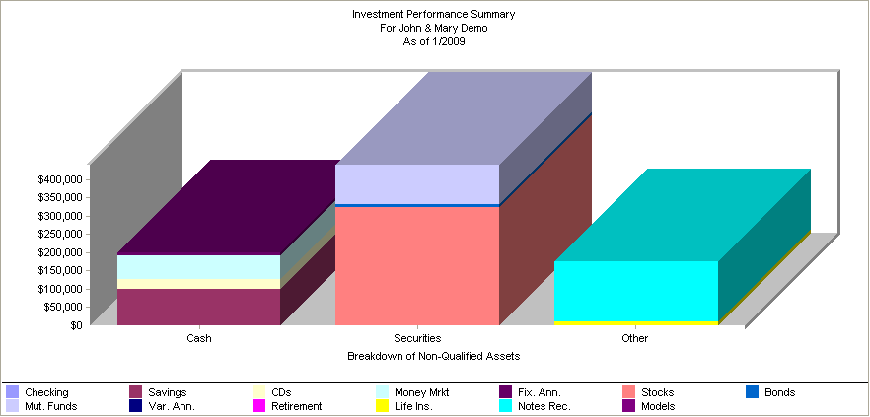

FIXED ANNUITY
Qualified Fixed Annuity c 1/88 1.000 7,000 10,000 3,000 1,000.00 1,000 14.29% 10.00%
10,000 1.12%
RETIREMENT PLAN
Military Pension s 1/2 1.000 0 0 0 0.00 0 N/A N/A
IRA - John c 3/81 1.000 0 24,000 24,000 0.00 0 N/A 0.00%
IRA - Mary s 3/81 1.000 0 15,900 15,900 0.00 0 N/A 0.00%
39,900 4.46%
VARIABLE ANNUITY
Qual. Variable Annuity c 1/88 2,000.000 18,000 20,000 2,000 0.08 160 0.89% 0.80%
20,000 2.24%

Total Qualified Assets 25,000 69,900 44,900 1,160 4.64% 1.66% 69,900 7.82%

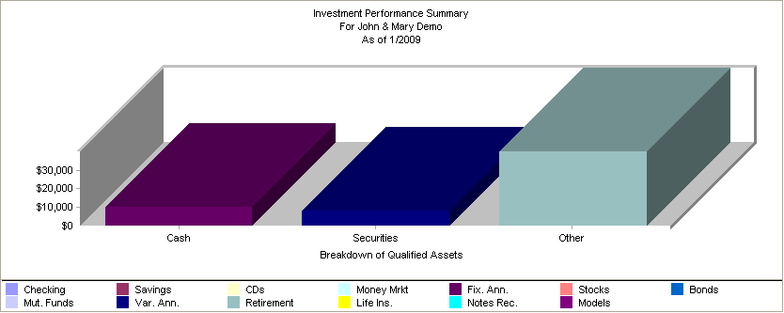



Total Market Value $ 893,706.22

